Artifacts include items that were made or used by people long ago. Some Aboriginal artifacts are known as historical cultural items.
My name is ___________________________________________________ 4A
Remains of the Past:
Archaeologists study buildings and objects from the past. These objects are often buried, and archaeologists dig carefully to uncover them.
There is a way we learn about Alberta’s past. In some parts of the province, remains have been uncovered of objects that were used by people who lived here in the past. The scientists who uncover these remains are called archaeologists. The remains that they uncover are called artifacts. Artifacts include items that were made or used by people. Archaeologists use scientific methods to find out when artifacts were made. They piece together remains, and information about artifacts, to build a picture of how people may have lived in the past.
Archaeologists have found tepee rings in the grasslands like the one shown in the photograph below. Teepee rings are circles of stones that once held down the bottom edges of teepees. Archaeologists can tell that these tepee rings are thousands of years old.
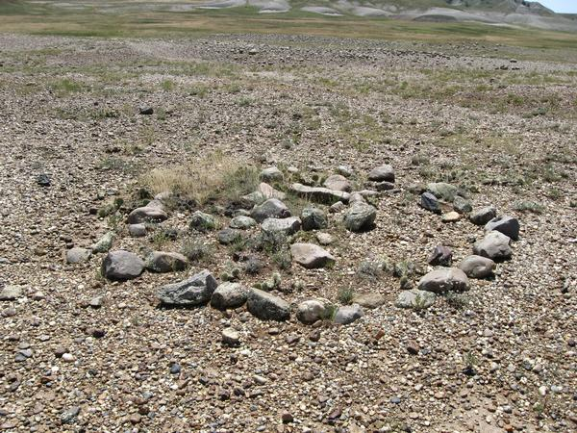
Image taken from: http://c1.ac-images.myspacecdn.com/images02/56/l_f3dc9742cd5247e2bc4765c3dc411fd4.jpg on March 24, 2011.
Why do you think just the stones have been found, but none of the other parts of the teepee?
___________________________________________________________________
__________________________________________________________________
__________________________________________________________________

The Creator’s Gift:
(As told by Sandra Crazy Bull of the Kainai First Nation: Interpreter Glenbow Museum)
The Blackfoot people believe that the buffalo was the Creator’s gift to us. The buffalo was our primary food, and much more. We didn’t hunt randomly. Before a group would go out to hunt, the people would conduct a ceremony . . . . They would pray for the people going to hunt, and for the beings to be hunted. They would give thanks to the buffalo for giving himself to us for so many things we needed. They would sing a buffalo song. Then they would go to the buffalo jump. So there was a ceremony, and prayer, and song, and then the hunt.
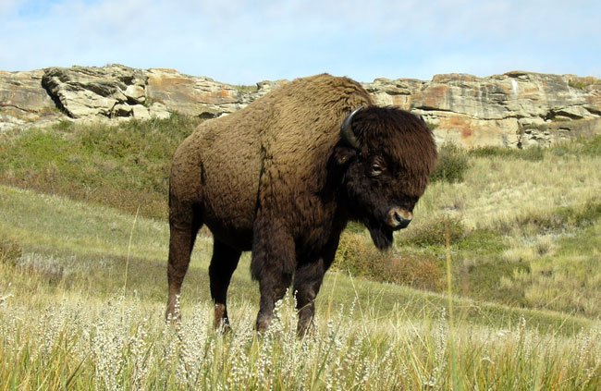
Image taken from: http://www.visitcalgary.com/things-to-do/arts-attraction/galleries-museums/head-smashed-buffalo-jump-interpretive-centre on Feb. 10, 2016.
1. Why do you think the Blackfoot did not hunt randomly?
___________________________________________________________________
2. Before the hunt, what did the Blackfoot do?
___________________________________________________________________
___________________________________________________________________
3. What do you think is meant by “buffalo jump”? If you go to Google (if you have access to a computer at home) and type in “” what can you learn?
______________________________________________________________________
______________________________________________________________________
______________________________________________________________________

