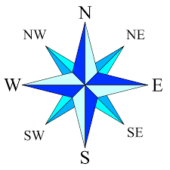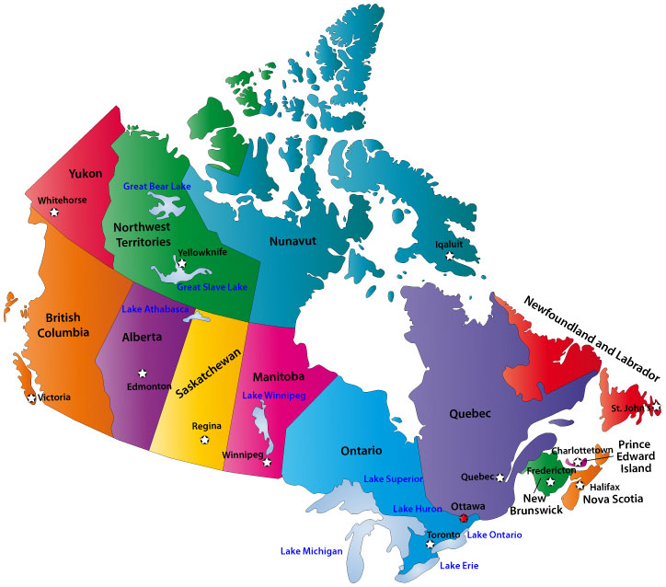
Name: _____________________________________ Date: ___________________________

Downloaded from: http://www.map-of-canada.org/about.htm

Practice the Skill:

Use the compass rose and the map of Canada above ⬆ to answer these questions:

1. Which province is west of Alberta? _____________________________________________________

2. Which territories are north of Alberta? _________________________________________________

_________________________________________________________________________________________________

3. In which direction do you go from Alberta to reach Manitoba? _______________________

4. Which provincial capital city is southwest of Edmonton? _____________________________

5. Which compass direction is halfway between south and east? _______________________

6. Which direction do you go from Edmonton to reach Iqaluit? _________________________

