You need to write out a little paragraph following the same format as the one below. You will need to identify all 6 items in your backpack. Also, include a sentence with 2 items you would find in the classroom.
Your sentences will start with Dans mon sac à dos, il y a.... which means in my backpack there is/are…

In your duo tang is the school vocabulary in your dictionary, you will change the la/le/les to the indefinite articles below. If you are adding numbers in front, do not add the indefinite articles below:

la = une et = and
le = un
les = des

Here is an example of what your paragraph should look like if these things were in your backpack:

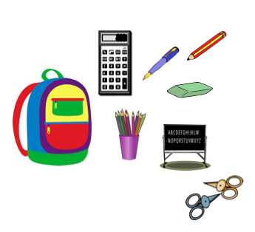
Bonjour! Je m' appelle Susie. Je vais á l'école Nose Creek. Dans mon sac à dos il y a une calculatrice, une bâton de colle et cinq stylos. Dans mon sac à dos il y a huit crayons, vingt-quatre crayons de couleur et deux gommes.
Dans la salle de classe il y a des ciseaux et un tableau blanc.
______________________________________________________________________________________________________________________________________________________________________________________________________________________________________________________________________________________________________________________________________________________________________________________________________________________________________________________________________________________________________________________________________________________________________________________________________________________

